Algorithm for file updates in Python

Project description
Developed a Python algorithm to automate the management of an IP address allow list for a restricted network sub-system within a simulated healthcare organization. The goal was to enforce the principle of least privilege by regularly updating the list of authorized IPs. The script efficiently handles file I/O, converts data, and uses iterative logic to revoke unauthorized access. This automation enhances security by minimizing human error and ensuring rapid policy enforcement.

Open the file that contains the allow list
In this step, the algorithm prepares to read the existing list of authorized IP addresses from the file, ensuring the file is handled safely.
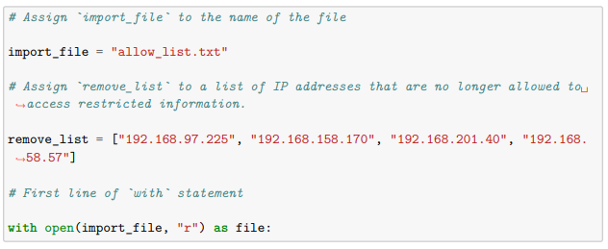
1. import_file: A string variable that stores the name of the file being managed. 2. with statement: This crucial keyword ensures safe file handling. It guarantees that the file is automatically closed, even if errors occur, preventing resource leaks. 3. open() function: Opens the file. The argument 'r' specifies the read mode, indicating the file will be read from. 4. as file: Assigns the file object to the variable file for temporary use.

Read the file contents
The file contents are converted from a stream of bytes into a single, workable string.

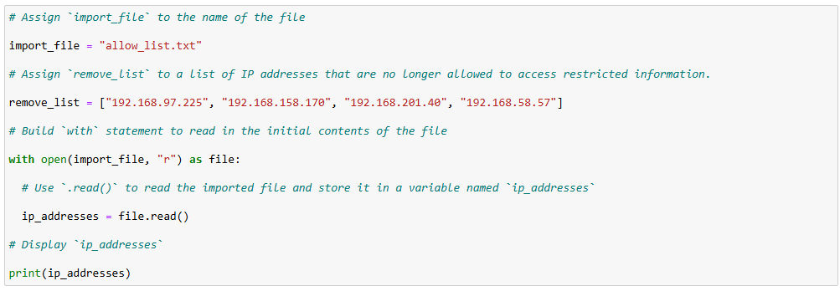
Output:
ip_address
192.168.25.60
192.168.205.12
192.168.97.225
192.168.6.9
192.168.52.90
192.168.158.170
192.168.90.124
192.168.186.176
192.168.133.188
192.168.203.198
192.168.201.40
192.168.218.219
192.168.52.37
192.168.156.224
192.168.60.153
192.168.58.57
192.168.69.116
1. .read() method: This method is called on the file object (file) to read the entire contents of the file into a single, multi-line string. 2. ip_addresses: The resulting string, which contains all the IP addresses (separated by newline characters), is stored in this variable.

Convert the string into a list
To enable efficient iteration and removal of individual IP addresses, the single string must be broken down into discrete elements (a list).

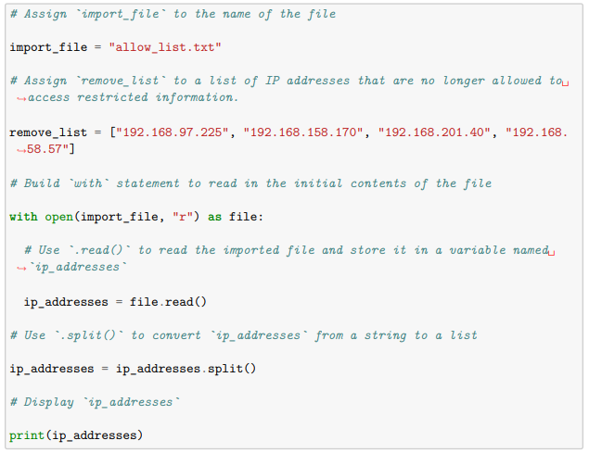Output:
['ip_address', '192.168.25.60', '192.168.205.12', '192.168.97.225', '192.168.6.9', '192.168.52.90', '192.168.158.170', '192.168.90.124', '192.168.186.176', '192.168.133.188', '192.168.203.198', '192.168.201.40', '192.168.218.219', '192.168.52.37', '192.168.156.224', '192.168.60.153', '192.168.58.57', '192.168.69.116']
1. .split() method: This method is called on the ip_addresses string. When used without arguments, it splits the string at every instance of whitespace (including spaces and newlines), transforming the single string into a list where each IP address is a separate element.

Iterate through the remove list
The algorithm must check every IP address slated for removal against the current allow list.

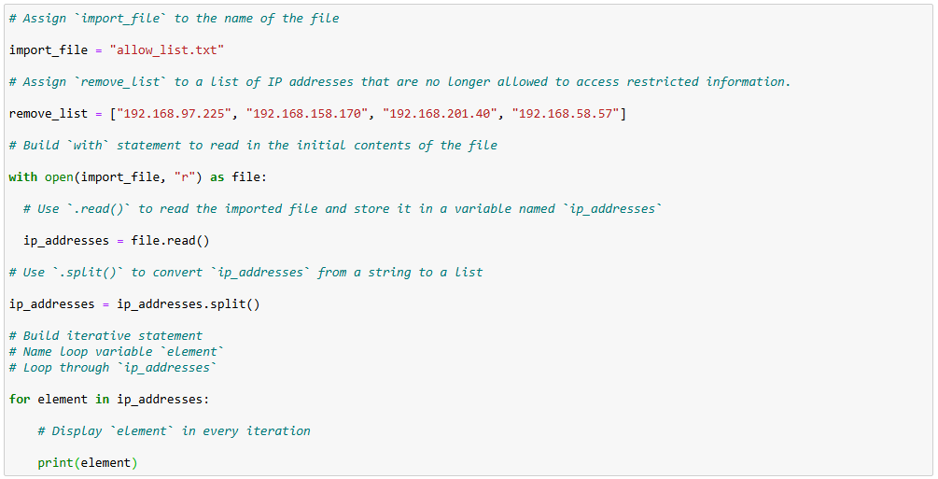
Output:
ip_address
192.168.25.60
192.168.205.12
192.168.97.225
192.168.6.9
192.168.52.90
192.168.158.170
192.168.90.124
192.168.186.176
192.168.133.188
192.168.203.198
192.168.201.40
192.168.218.219
192.168.52.37
192.168.156.224
192.168.60.153
192.168.58.57
192.168.69.116
1. for loop: This keyword initiates the iterative statement, telling Python to repeat the code block for every item in a sequence. 2. remove_list: The sequence (list) containing the IP addresses that must be checked. 3. element: The loop variable that holds the value of the current IP address being processed during each cycle.

Remove IP addresses that are on the remove list
This step applies the security policy: if an IP is on the remove list, it must be deleted from the allow list.

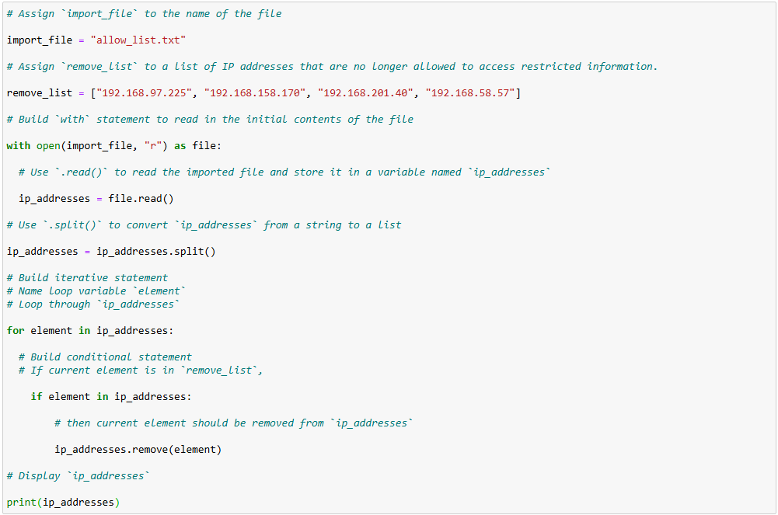
Output:
['ip_address', '192.168.25.60', '192.168.205.12', '192.168.6.9', '192.168.52.90', '192.168.90.124', '192.168.186.176', '192.168.133.188', '192.168.203.198', '192.168.218.219', '192.168.52.37', '192.168.156.224', '192.168.60.153', '192.168.69.116']
1. if statement & in keyword: This conditional checks for membership. If the current element (IP to be removed) is present in the ip_addresses list, the condition is true. 2. .remove(element) method: This list method is called to delete the first occurrence of the specified element from the ip_addresses list.

Update the file with the revised list of IP addresses
The final step converts the updated list back into a file format and overwrites the original file to enforce the new access policy.

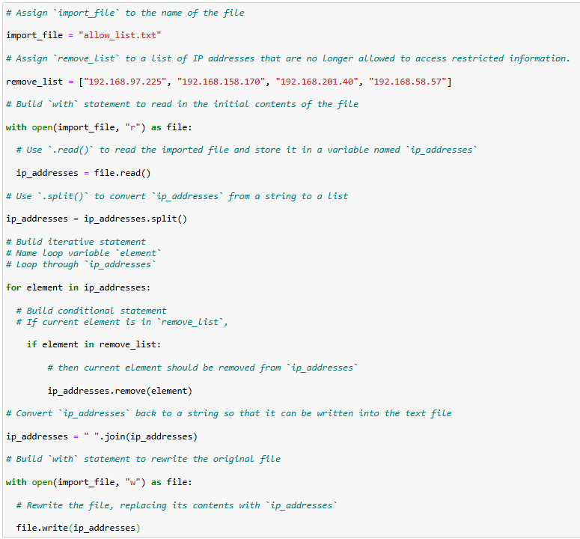
1. .join() method: Called on the string "\n" (the newline character), this method converts the list back into a single string, using the newline character to place each IP on a separate line for file output. 2. open(..., 'w'): The open() function is used with the mode 'w' for write mode. This is critical as it overwrites and deletes all contents of the file before writing, effectively applying the updated access list. 3. .write() method: This method writes the entire updated string of IP addresses into the allow_list.txt file.

Summary
The algorithm successfully automates the critical task of maintaining an IP address allow list, significantly contributing to the security of patient data. The process begins with safe file handling using a with open(..., 'r') statement to read the existing list. The contents are transformed from a single string into a manipulable list using the .split() method, which is essential for working with individual IP addresses. A for loop then systematically checks each IP in the removal list against the allow list, utilizing the .remove() method to securely revoke access. Finally, the revised list is converted back into a file-friendly string using the .join() method, and the access control file is securely overwritten using with open(..., 'w') and the .write() method. This automated solution is scalable, reliable, and crucial for enforcing the principle of least privilege.

